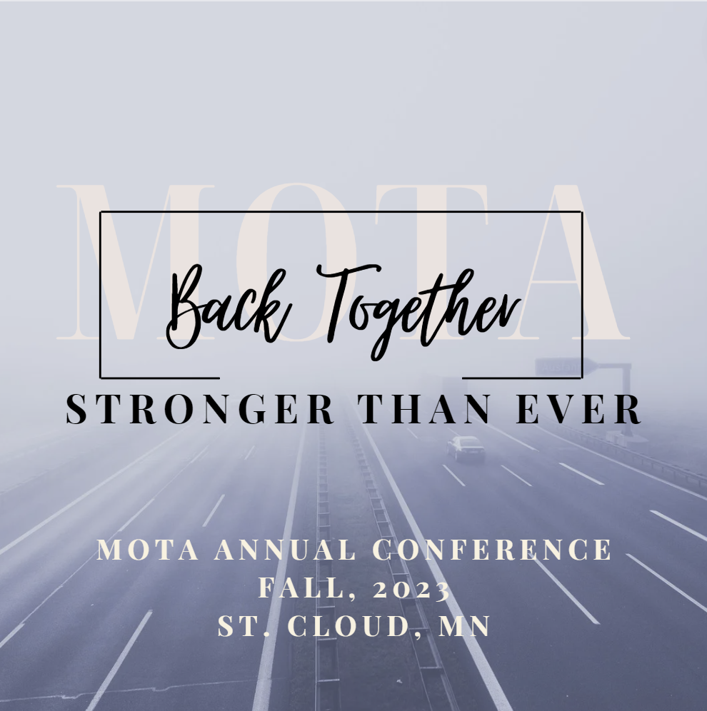
Call for Presentations January 3-February 10, 2023
Virtual and Live Presentations, Panel Discussions, and Conversations that Matter
MOTA will continue to provide a virtual forum for high-quality, relevant professional development AND a live conference this fall! We are especially interested in coming back together, stronger than ever, with the strength we gained from reflecting and re-visioning during the pandemic.

Provide us with some information on what you are interested in sharing, and we will guide you through the process!

Yes! I am interested in presenting!
Please take 5 minutes to fill out this interest form.
A MOTA representative will reach out to you.

Name and Credentials:
Contact Information (email and phone):
Please choose one or both of the following opportunities:
- I would like to present at the live Conference, in Fall, 2023 in St. Cloud, MN
- I would like to present virtually between March-August, 2023
Dates you are available to present: (typically M-W)
1st Choice:
2nd Choice:
3rd Choice:
Topic and/or Title:
Format of Presentation: How would I like to share my knowledge and experience?
- Presentation: typically involves slides or other visual supports and may also involve a question and answer period. Some presenters also allow questions throughout the presentation.
- Panel Discussion: scripted discussions between panel members about a specific topic. Each panel member contributes their ideas or perspective on various aspects of that topic.
- Conversation that Matters: discussion with the audience on topics that are current and relative to our profession. As a facilitator, you will provide some basic information about specific aspects of a topic, provide discussion prompts, and guide a conversation with the audience.
- Occupation Station: This format is for exhibitors or presenters who would like to provide an informational and experiential lab. Participants will learn the objectives and evidence supporting your materials and be able to practice using them.

Length of Presentation (typically 60-90 minutes):

Please complete and download this interest form and email it by Feb. 10, 2023 to: motafunctionfirst@gmail.com

